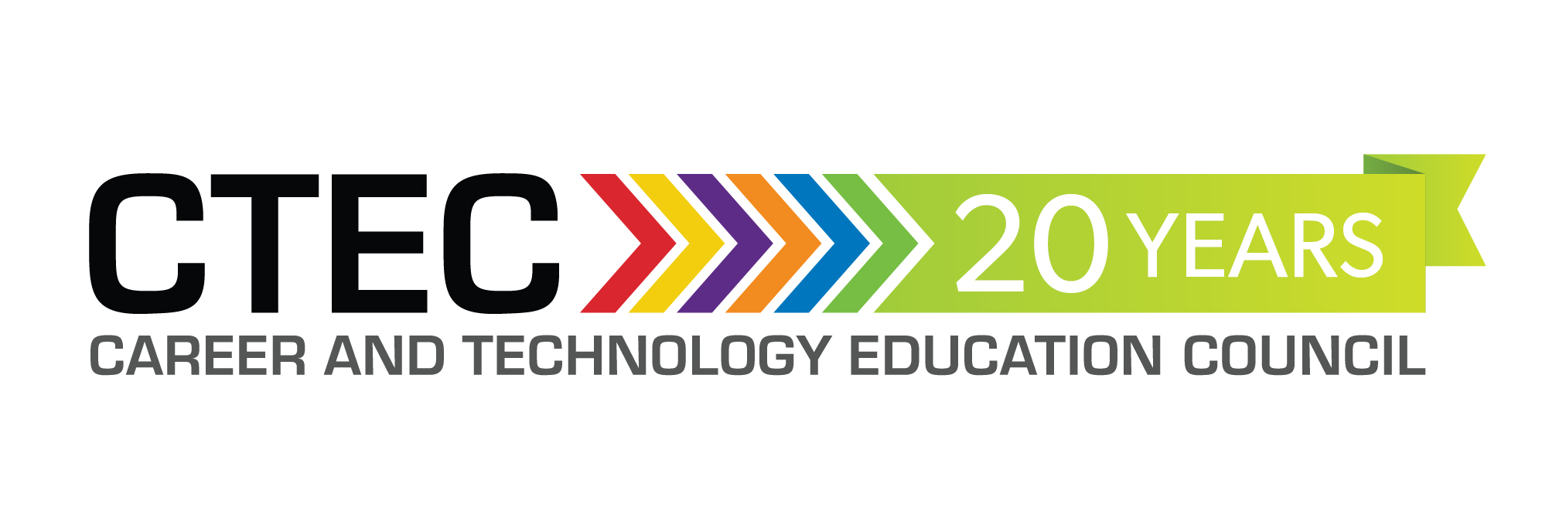

CTEC CONFERENCE 2017
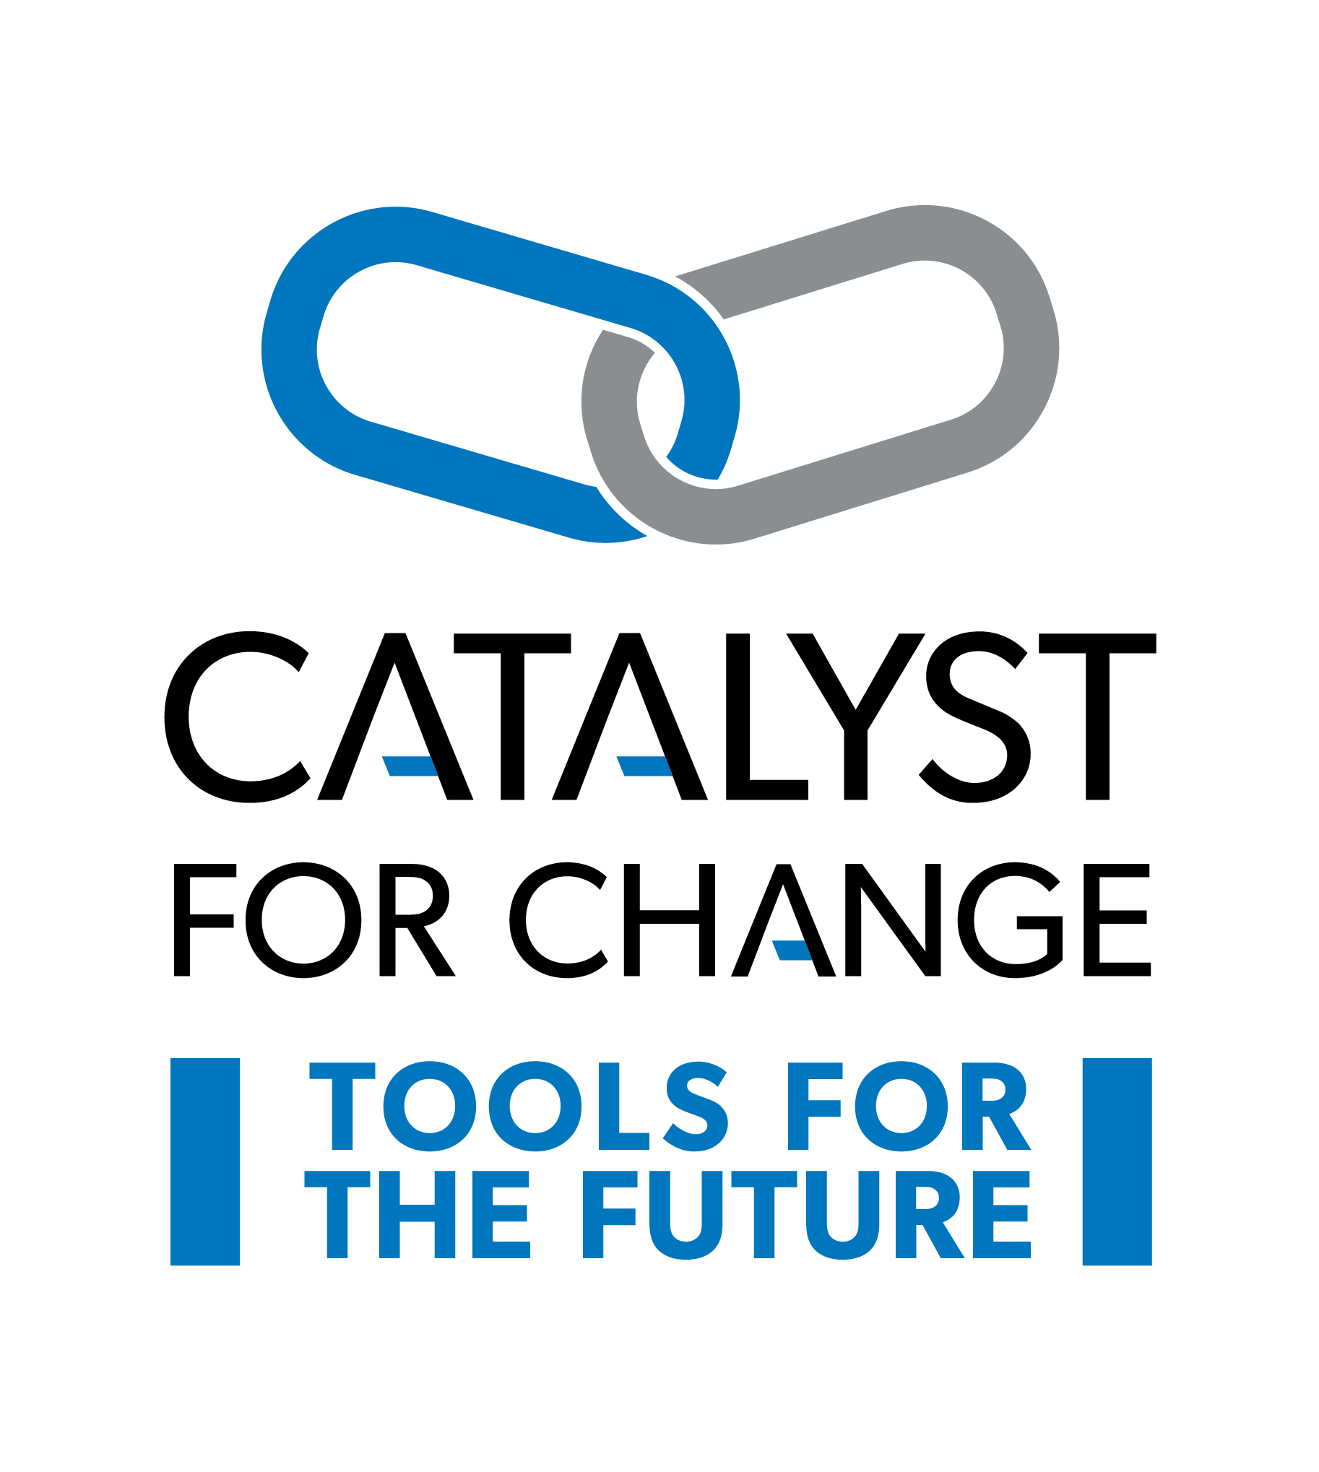
NOVEMBER 23 – 25, 2017
Coast Canmore Hotel and Conference Centre
Canmore, Alberta

DELEGATE REGISTRATION INFORMATION

Are you a Career and Technology Foundations (CTF) (GR. 5 – 9) teacher?

Are you a Career and Technology Studies (CTS) (GR. 10 – 12) teacher?

Then this conference is for you!

Join colleagues, at the Coast Canmore Hotel and Conference Centre, November 23 – 25, 2017, for the annual Career and Technology Education Council Conference (CTEC). You will have an opportunity to learn new skills, gather new information, attend workshops, visit with vendors to learn about new tools, equipment and materials, share successes, collaborate and network with colleagues from across Alberta that will enrich student learning, engagement and health and safety best practices in trades, technology and occupations across all sectors of the economy.

We believe that providing CTEC teachers with direct contact to colleagues, business, industry and organization stakeholders allows teachers to share their knowledge and relevant experiences with their students, to create dynamic, authentic, learning environments.

See you there!
DELEGATE REGISTRATION INFORMATION

Delegate Contact Information

Name: _________________________________________________________________________________________

School: ________________________________________________________________________________________

Jurisdiction: _____________________________________________________________________________________

Email: __________________________________________________________________________________________

Phone: __________ Address: _________________________________________________________

City/Prov.: _________________________________________ Postal Code: _______________________________

Cluster Category: Please select (check) all the CLUSTERS that you teacher or may be ‘connected’ to:
BIT  Business, Administration, Finance & Information Technology | HRH  Health, Recreation & Human Services | MDC  Media, Design & Communication Arts | NAT  Wildlife, Forestry, Energy, Agriculture & Environmental Stewardship |  | TMT  Trades, Manufacturing, Transportation | CTF  Middle Years Career and Technology Foundations  Gr. 5 – 9  Options | GEN  Assessment  Classroom Management  Alberta Ed & ATA Updates | OTHER  Please Specify
Identify which OCCUPATIONS you teach or work with most:
- Computing Science (CSE)  - Enterprise and Innovation (ENT)  - Financial Management (FIN)  - Information Processing (INF)  - Management & Marketing (MAM)  - Networking (NET) | - Community Care Services (CCS)  - Cosmetology (COS)  - Community Care Services (CC  - Criminal Justice Studies (CJS)  - Foods (FOD)  - Health Care Aide (HCA)  - Health Care Services (HCS)  - Human and Social Services (HSS)  - Community Care Services (CCS)  - Recreation Leadership (REC)  - Tourism (TOU) | - Communication Technology (COM)  - Design Studies (DES)  - Design Studies (DES) |  | - Agriculture (AGR)  - Environmental Stewardship (ENS)  - Forestry (FOR)  - Primary Resources (PRS)  - Wildlife (WLD) | - Construction (CON)  - Electro-Technologies (ELT)  - Fabrication (FAB)  - Logistics (LOG)  - Mechanics (MEC) | - Business  - Communication  - Human Services  - Resources  - Technology | - __________  - __________  - __________  - __________  - __________ | - __________  - __________  - __________  - __________  - __________

Please complete this information using it as a guide / worksheet to calculate your Conference costs and click here to go to the link and register thru Event Wizard.

DELEGATE REGISTRATION INFORMATION WORKSHEET | NUMBER | UNIT COST | TOTAL
REGISTRATION – includes:
- Healthy Options Preconference,
- Thursday Evening Keynote and Networking Reception
- Friday Breakfast, Lunch and Dinner Keynotes
- Friday Evening - Heavy Metal Gala - for one and all! You do NOT need to be a metal head to enjoy this evening out!! Unbelievable precious metal prizes, great ol' Rock music trivia, food and drink, press-on "Tattoos" for the young at heart, dress up photo booth, live music, entertainment, and a Funtastic time for all!!! Door prizes throughout the evening, & grand prize draw at the end of the evening! See you in your best heavy metal gear!
- Saturday AGM
- Networking Post Conference Sessions
- Meals: 2 breakfasts; 2 lunches; 1 dinner; mid-morning and mid-afternoon Refreshment and Networking Opportunities; Thursday Evening Networking Reception
CTEC Member Fee (EARLY BIRD REGISTRATION – Payment received prior to September 15, 2017 - $400.00) |  | $425.00
Non-Member Delegate (includes 1 year membership in CTEC) Fee: |  | $460.00
Student Delegate Fee (includes 1 year membership in CTEC) |  | $325.00
Non-ATA Delegate Fee  (Persons Not Eligible for Specialist Council Membership – Central Office Staff who did not elect active ATA Membership cannot be members of Specialist Councils. The superintendent, deputy superintendent of school jurisdictions and teachers in charter, federal or private schools must be ATA Associate members in order to qualify for Specialist Council Membership.) |  | $650.00
EXTRA MEAL PACKAGES (each) |  | $200.00
TOTALS
Please complete this information using it as a guide / worksheet to calculate your Conference costs and click here to go to the link and register thru Event Wizard.
Cancellations will be accepted on or before October 15, 2017.
No refund will be provided after this date.
Cancellations on or before October 15, 2017 will be charged a $45 cancellation fee.
"No Shows" will not be eligible for a refund.
Specialist council memberships are non-refundable.
ACCOMODATIONS – please book directly through Coast Canmore Hotel and Conference Centre (prices do not include taxes):  Room Single Rate Double Rate  Comfort Queen 134 134  Comfort Room King 134 134  Superior Queen 144 144  Superior King 144 144  Premium King 154 154  Jetted-Tub Suite 229 229  Free WIFI, Free Local Calls, Work Desk, 42″ Flat Screen TV, Coffee Service, A/C  NOTE: SKIP STEP #3 – Customize Your Stay – meals are included in the conference package | N/A |  | N/A
Go to: http://coa.st/bcui and follow the prompts OR
Phone central reservations on toll free number 1.800.716.6199 and quoting group code ‘CCM-GF414’or group name ‘Career and Technology Studies of ATA’

ORGANIZATION DETAILS

- Ballroom Exhibits, Meals and Socials
All delegate meals will be held in the Ballroom. The ‘Networking Café’ will also be held in the ballroom. Multiple 15 - 30 minute presentations will be conducted throughout the conference.
- Thursday Evening Keynote and Networking Reception
– networking opportunity
- Heavy Metal Celebration – join colleagues to network and share in the fun themed evening with great music provided by Mahoney; evening reception included
(Door prize draws throughout the evening!)

- Lobby – CTEC Check-in
The lobby is situated immediately outside the Ballroom where meal buffet lines and nutrition breaks will be available
CTEC REGISTRATION

