CTEC CONFERENCE 2017
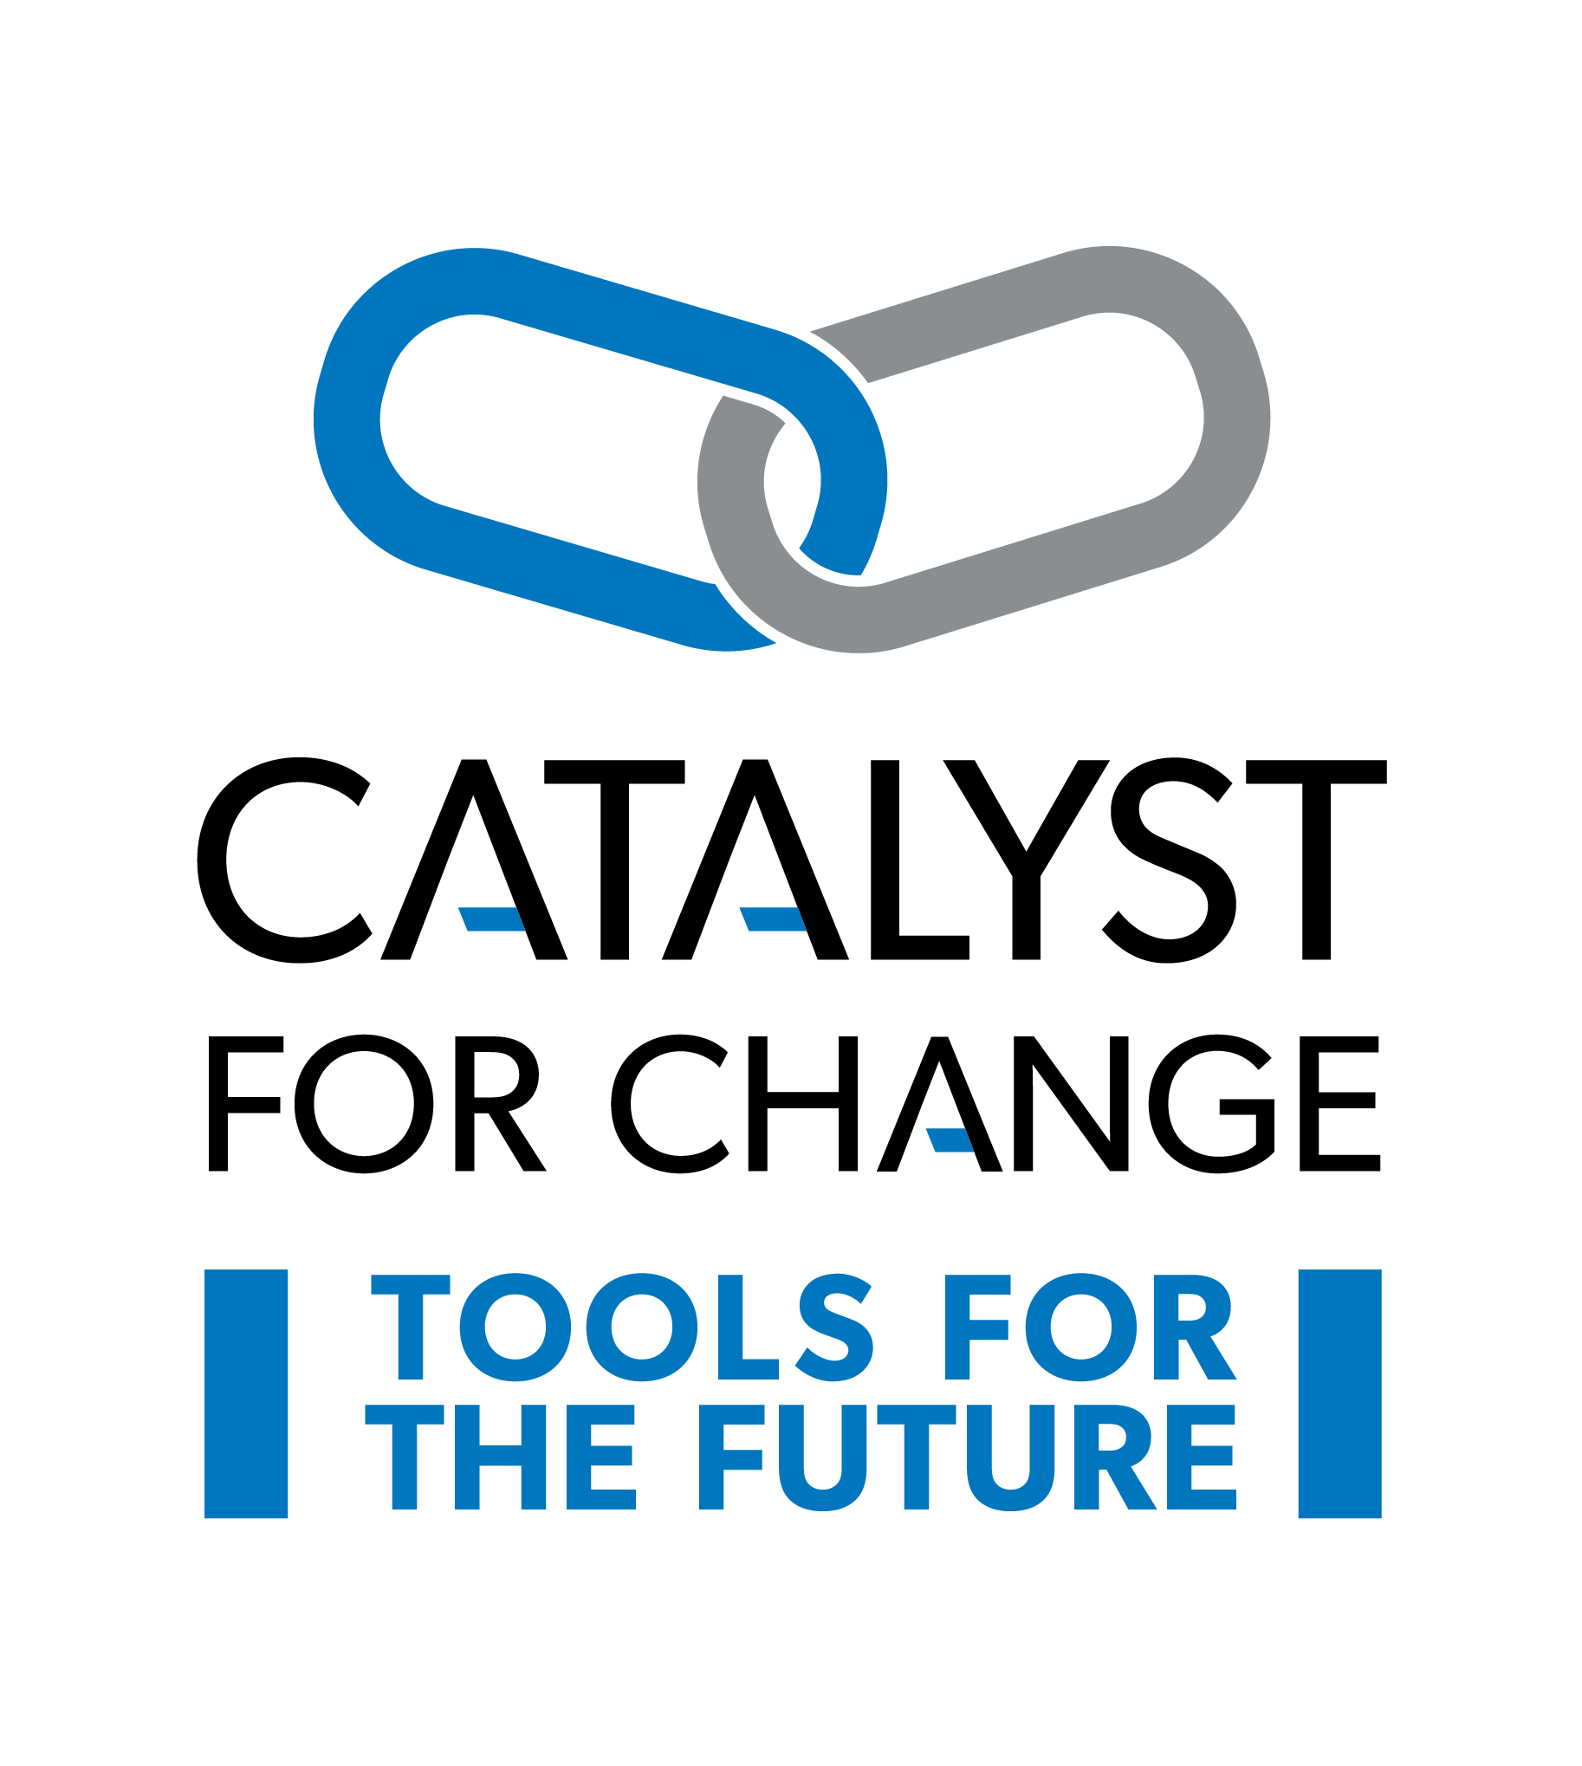
NOVEMBER 23 – 25, 2017
Coast Canmore Hotel and Conference Centre
Canmore, Alberta

SPEAKER PROPOSAL FORM

Thank you for your interest in presenting a session at the CTEC Conference! Presentations / sessions are great professional development opportunities to share knowledge, skills, assessments, new tools, equipment, materials, procedures or simply network with educators and colleagues. Please take a moment to review the entire form prior to completing.

We believe that providing CTEC teachers with direct contact to colleagues, business, industry and organization stakeholders allows teachers to share their knowledge and relevant experiences with their students, to create dynamic, authentic, learning environments. Please ensure you complete all parts of the form. Thank you.

See you there!

Unfortunately, proposals with incomplete details cannot be processed.
Please email completed form to: conferencedirector@ctscouncil.com

For more information about our conference, please visit our website at:
http://ctec.teachers.ab.ca/conferences

SPEAKER CONTACT INFORMATION
Name(s):
Address:
Phone (Business): | ( ) | Phone (cell): | ( )
Fax: | ( ) | Email:

SESSION INFORMATION
Session Title:
Other Speaker Names:

Cluster Category: Please select (check) all the CLUSTERS that you teacher or may be ‘connected’ to:
BIT  Business, Administration, Finance & Information Technology | HRH  Health, Recreation & Human Services | MDC  Media, Design & Communication Arts | NAT  Wildlife, Forestry, Energy, Agriculture & Environmental Stewardship |  | TMT  Trades, Manufacturing, Transportation | CTF  Middle Years Career and Technology Foundations  Gr. 5 – 9  Options | GEN  Assessment  Classroom Management  Alberta Ed & ATA Updates | OTHER  Please Specify
Identify which OCCUPATIONS you teach or work with most:
- Computing Science (CSE)  - Enterprise and Innovation (ENT)  - Financial Management (FIN)  - Information Processing (INF)  - Management & Marketing (MAM)  - Networking (NET) | - Community Care Services (CCS)  - Cosmetology (COS)  - Community Care Services (CC  - Criminal Justice Studies (CJS)  - Foods (FOD)  - Health Care Aide (HCA)  - Health Care Services (HCS)  - Human and Social Services (HSS)  - Community Care Services (CCS)  - Recreation Leadership (REC)  - Tourism (TOU) | - Communication Technology (COM)  - Design Studies (DES)  - Design Studies (DES) |  | - Agriculture (AGR)  - Environmental Stewardship (ENS)  - Forestry (FOR)  - Primary Resources (PRS)  - Wildlife (WLD) | - Construction (CON)  - Electro-Technologies (ELT)  - Fabrication (FAB)  - Logistics (LOG)  - Mechanics (MEC) | - Business  - Communication  - Human Services  - Resources  - Technology | - __________  - __________  - __________  - __________  - __________ | - __________  - __________  - __________  - __________  - __________

SPEAKER PREFERENCES: (check all applicable)
Time Block:
Friday Morning |  |  | Friday Afternoon |  |  |  | Saturday Morning |  |  |  |  |  | No preference
Length of Session:
50 min. |  |  |  |  |  |  | Half Day: 2.5hrs
Type of Session:
Lecture |  |  |  |  |  |  | Hands-On (specify)
Audio-visual needs: Free Wi-Fi throughout the hotel
NOTE: |  | ** We are unable to provide computers and adapters for presenters.  ** We are only able to provide LCD projectors for presenters in session rooms.
LCD Projector/screen in  session room |  |  |  |  |  |  | No AV Needed
Would you be willing to repeat your session?
Every attempt will be made to schedule this repeat session in a mutually convenient time slot. |  |  |  | Yes |  |  |  |  |  |  | No
Best day? |  |  |  | Friday |  |  |  |  | Saturday |  |  |  |  | No preference
Best Time slot? |  |  |  | AM |  |  |  |  | PM |  |  |  |  | No preference

A committee member will be in touch to finalize details as the conference date gets closer.

Thank you!

DESCRIPTION OF PRESENTATION TO APPEAR ON THE CONFERENCE WEBSITE.

Please include a precise session description to publicize on the conference website. The description is limited to 350 characters. The CTEC Conference program committee reserves the right to edit descriptions.

SPEAKER’S BIOGRAPHY
Please note any relevant biographical information to be included on the conference website. The Speaker’s Biography is limited to 300 characters. CTEC Conference program committee reserves the right to edit the Speaker’s Biography.
The CTEC Council is unable to pay for photocopying and hotel costs (meals & rooms) for the presenter(s). Thank you for your proposal. Please e-mail questions and presentation proposal to conferencedirector@ctscouncil.com

SPEAKER REGISTRATION DETAILS |  | NUMBER |  | UNIT COST | TOTAL
CTEC Conference Registration – 50 minute or longer session  (Offer is for one Conference Registration for One Speaker/Presenter)  Includes:  Healthy Options Preconference,  Thursday Evening Keynote and Networking Reception  Excludes hotel accommodation and meal package(s). |  |  |  | NO COST
MEAL PACKAGE/S (each) |  |  |  | $200.00
Friday Evening - Heavy Metal Gala - for one and all! You do NOT need to be a metal head to enjoy this evening out!! Unbelievable precious metal prizes, great ol' Rock music trivia, food and drink, press-on "Tattoos" for the young at heart, dress up photo booth, live music, entertainment, and a Funtastic time for all!!! Door prizes throughout the evening, and grand prize draw at the end of the evening! See you in your best heavy metal gear! |  |  |  | $30.00  per person
TOTALS
Please complete this information using it as a guide / worksheet to calculate your Conference costs and click here to go to the link and register thru Event Wizard.
ACCOMODATIONS – please book directly through Coast Canmore Hotel and Conference Centre (prices do not include taxes):  Room Single Rate Double Rate  Comfort Queen 134 134  Comfort Room King 134 134  Superior Queen 144 144  Superior King 144 144  Premium King 154 154  Jetted-Tub Suite 229 229  Free WIFI, Free Local Calls, Work Desk, 42″ Flat Screen TV, Coffee Service, A/C  NOTE: SKIP STEP #3 – Customize Your Stay – meals are included in the conference package | N/A |  |  |  |  | N/A
Go to: http://coa.st/bcui and follow the prompts OR
Phone central reservations on toll free number 1.800.716.6199 and quoting group code ‘CCM-GF414’or group name ‘Career and Technology Studies of ATA’

Unfortunately, proposals with incomplete details or non-payment cannot be processed.
Please email all completed form to: conferencedirector@ctscouncil.com

For more information about our conference, please visit our website at:
http://ctec.teachers.ab.ca/conferences

