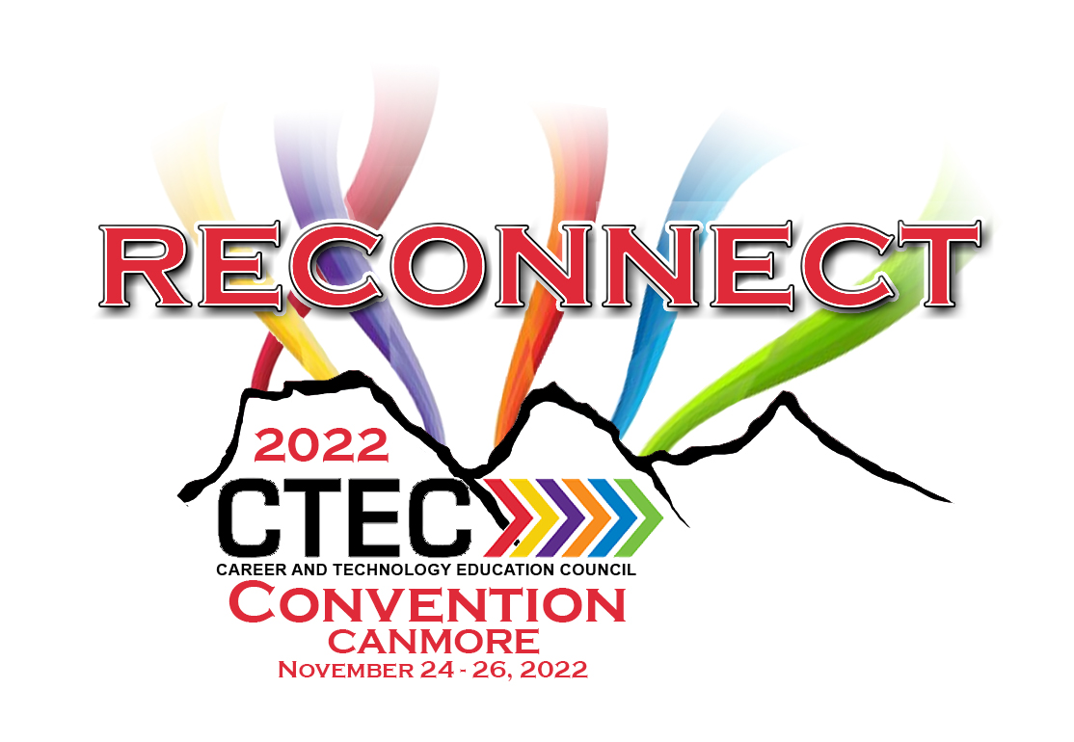

SPEAKER PROPOSAL FORM

CTEC CONFERENCE – 2022

Proposal Submissions are used to select sessions for the CTEC 2022 Conference,
Nov. 17 - 19 at the Canmore Coast Resort.

Proposal submission must be emailed to conferencedirector@ctecalberta.ca. Once your proposal has been reviewed a confirmation email and a speaker contract will be sent if your proposal is successful.

Contact Information

Name: ______________________ Email: __________________________

Address: _____________ School phone:

City/Prov: ____________ Cell phone:

Postal Code:

Speaker & Session Information:

Please complete the information below for all speakers at the session. They will be listed in the Conference Program.

Speaker #1 (First Name /Surname) Other Co-presenter Names:

1) _______________________ 2) ______________________

Title of Your Session: (10 words max.)

Subject Category:

BIT – Business, Administration, Finance & Information Technology Specific ______ TMT – Trades, Manufacturing & Transportation Specific _____ HRH – Health, Recreation & Human Services Specific _____ MDC – Media, Design & Communications Arts Specific _____ NAT – Natural Resources Specific _____

CTF – Career and Tech Foundations Specific _____

GEN – General Educational Sessions Specific _____

Other: _______________________________

Description of Presentation to appear in the Conference Program

Speaker’s Biography
Please note any relevant biographical information to be included in the Conference Program Book; Speaker’s Biography is limited to 300 characters. CTEC reserves the right to edit Speaker’s Biography.

PREFERENCES (we reserve the right to place session according to availability of facilities)

Time Block
Fri am - Field Trips Fri pm Sat am No Preference

Length of Session
30 min. 60 min. Half Day (2.5 hrs)
X
Would you be willing to repeat your session? Yes No

Intended Capacity _______ Maximum Delegates Minimum Delegates

Type of Session
Lecture Workshop Round Table Other ___________

Do you want your session to be pre registered
Yes No Length of time for final number

Audio-visual needs
LCD Projector Internet No AV Needed _______________

NOTE: ***** We are unable to provide computers for presenters.

Honoraria and Expenses - Choose the one that is applicable to your session above only!
Gift ($50 Value) - 30 minute session
Conference Registration waived $300 value
Can only be applied to one presenter per session! This excludes the meal package.)

The CTEC Council is unable to pay for photocopying, parking and hotel costs (meals & rooms) for the presenter(s).

Thank you for your proposal

